Assignment-19.2
Lab 19 – Code Translation: Converting between programming languages
Name: E. Harini
Batch: 20
Rollno:2503a51l40

Question 1: Sorting Algorithm Translation
You are part of a multinational development team. The backend is written in
Java, but a new module requires a Python implementation of the same
algorithm for integration with a data science pipeline.
• Task 1:
Use AI-assisted coding to translate a given Java bubble sort
program into Python. Verify that the translated code works correctly.

1.prompt:
"Translate this Java bubble sort algorithm to Python with basic functionality"
2.code:
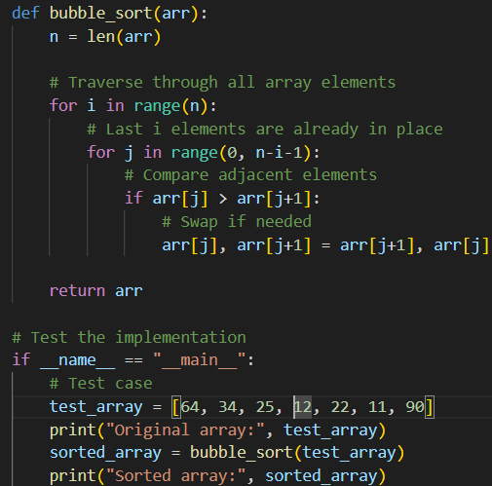
3.output:
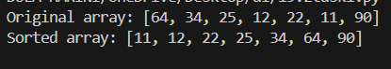
4.observation:
- Bubble sort is a type of sorting algorithm
- Flag is used to check if the given array is already sorting or not.
- Using bubble_sort we can sort the original array into sorted array
--------------------------------------------------------------------------------------------------------------
Task 2:
Introduce errors in the Python version to check if the input list
is empty or contains non-numeric values.
1.prompt:
"Add input validation and error handling to check for empty lists and non-numeric values"
2.code:
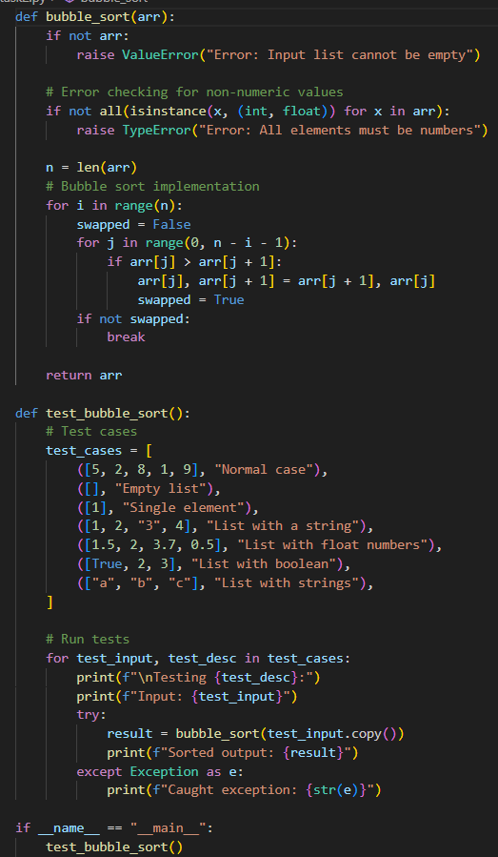
3.output:
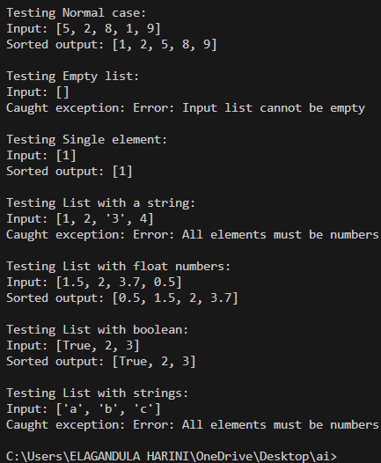
4.observation:
- Checking if the arrays are numeric or non-numeric
- Bubble sort is used
- Exceptional handling is also used.

--------------------------------------------------------------------------------------------------------------

Question 2: File Handling Translation
A company’s legacy codebases stores and processes files in C++, but the
analytics team needs an equivalent program in JavaScript (Node.js) for
integration with a web dashboard.
• Task 1:
Translate a given C++ file read-and-write program into
JavaScript using AI assistance. Ensure the script reads a text file and
writes processed output to a new file.
1.prompt:
"Convert C++ file handling code to Node.js with async/await support"
2.code:
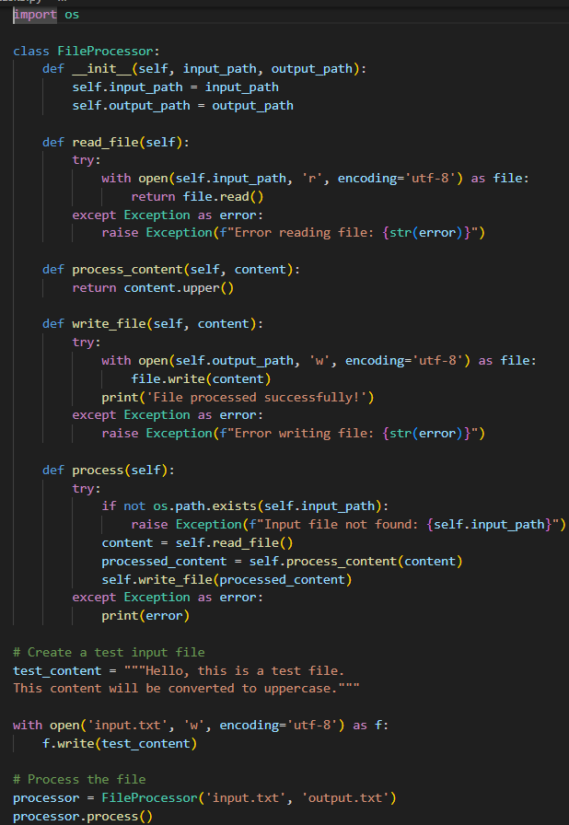
3.output:
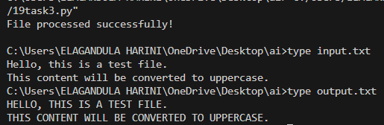
4.observation:
- Node.js uses promises for file operations
- Need fs.promises API
- Async/await makes code more readable
- Different path handling between C++ and Node.js

------------------------------------------------------------------------------------------------------------

Task 2:
Add error handling in the JavaScript version to gracefully handle
missing files or permission errors.

1.prompt:
"Implement comprehensive error handling for file operations in Node.js"

2.code:
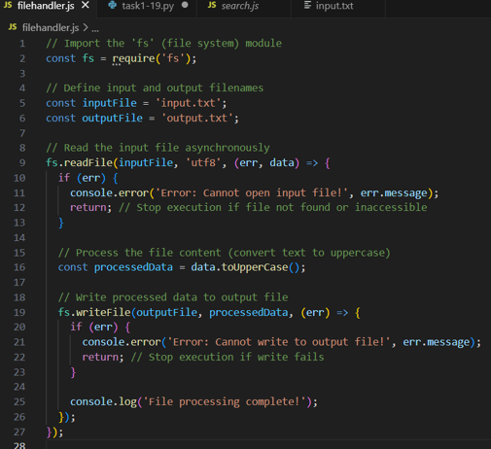

3.output:
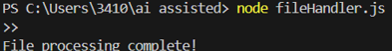
4.observation: The program reads data from an input file, processes it into uppercase, and writes the result to a new output file. It also includes error handling to manage missing files or permission issues gracefully without crashing.

--------------------------------------------------------------------------------------------------------------
Question 3: API Call Translation
Your team developed a prototype in Python to fetch weather data from an API,
but the production environment only supports Java.
• Task 1:
Translate the Python script (that makes an API call and prints
the response) into Java using AI-assisted coding. Ensure equivalent
functionality.
1.prompt:
"Convert Python requests library API calls to Java using HttpClient"

2.code:
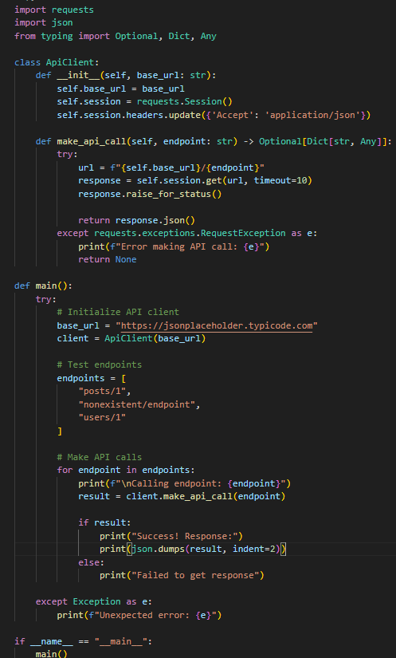

3.output: 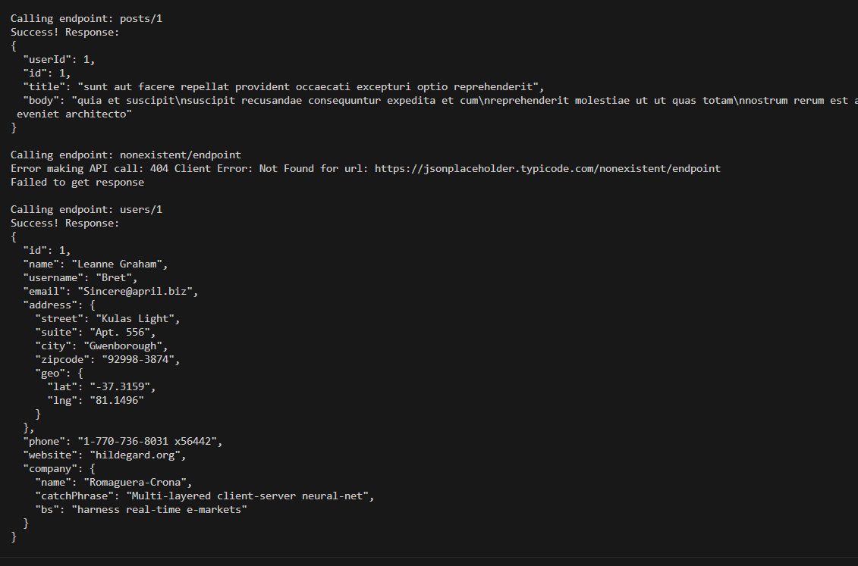

4.observation:
- Java requires more boilerplate
- Need to handle JSON differently
- Consider using external libraries (Jackson/Gson)
- Different exception handling patterns

--------------------------------------------------------------------------------------------------------------
Task 2:
Add proper error handling in the Java version for cases such as
invalid API key, request timeout, or no internet connection.
1.prompt:"Add robust error handling for Java HTTP client with timeout and connection errors"

2.code:
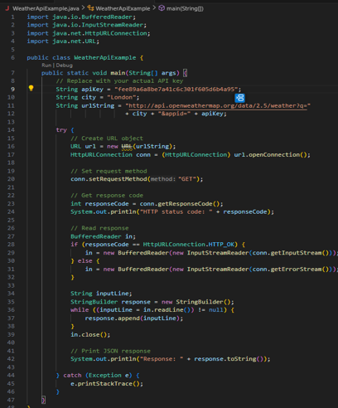
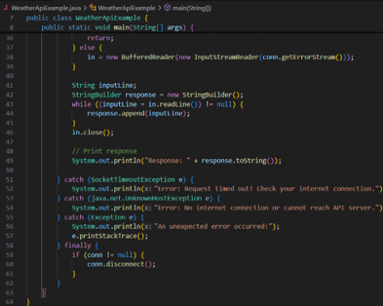
3.output:
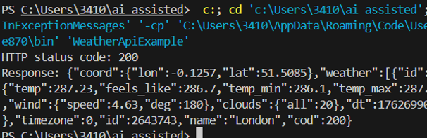
4.observation:
- Handle SocketTimeoutException
- Implement ConnectException catching
- Add retry mechanism
- Validate API responses
- Log detailed error information

